# 

**TMJ Contact Center Solution**

**Agent User Manual (Softphone)**

**Table of Contents**

**What is CCP?** 3

**Logging in to CCP (as an agent)** 3

**Changing the Agent Status** 5

**Answering/Rejecting Calls** 7

**Transferring Calls** 8

**Ending the Call** 11

**Logging out of CCP** 11

# **What is CCP?**

Contact Control Panel (CCP) is one of the many major features of Amazon Connect. It is a client interface used by agents to handle customer contacts.

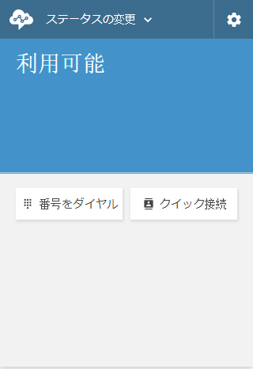

Figure 1. The Contact Control Panel (CCP)

# **Logging in to CCP (as an agent)**

* To start using the CCP, the agent should first log into their CCP account. Following this link will redirect you to the log in form of your account:

User Acceptance Testing (UAT) Link: <https://tmjccs-test.awsapps.com/connect/home>

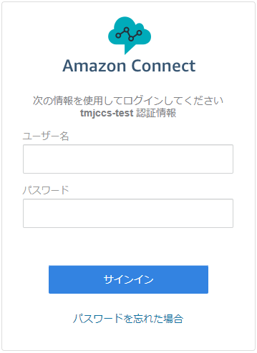

Figure 2. Amazon Connect Log-In Form

* Type your username and password in the input boxes. Then, click on the blue “Sign In” button.

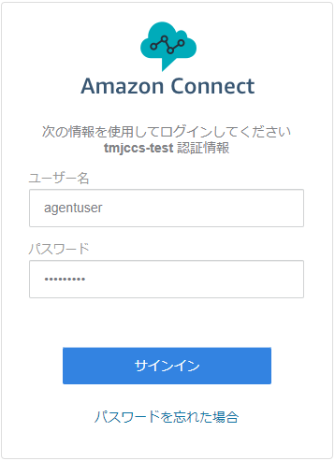

Figure 3. Inputting credentials in the Log-In Form

* Wait for a few moments and you will be redirected to Amazon Connect dashboard.

*Note: Agents don’t have access to other sections of Amazon Connect. Clicking on those links will result in an “Error 403 (Forbidden)”. You can ignore it or just go back to the previous page.*

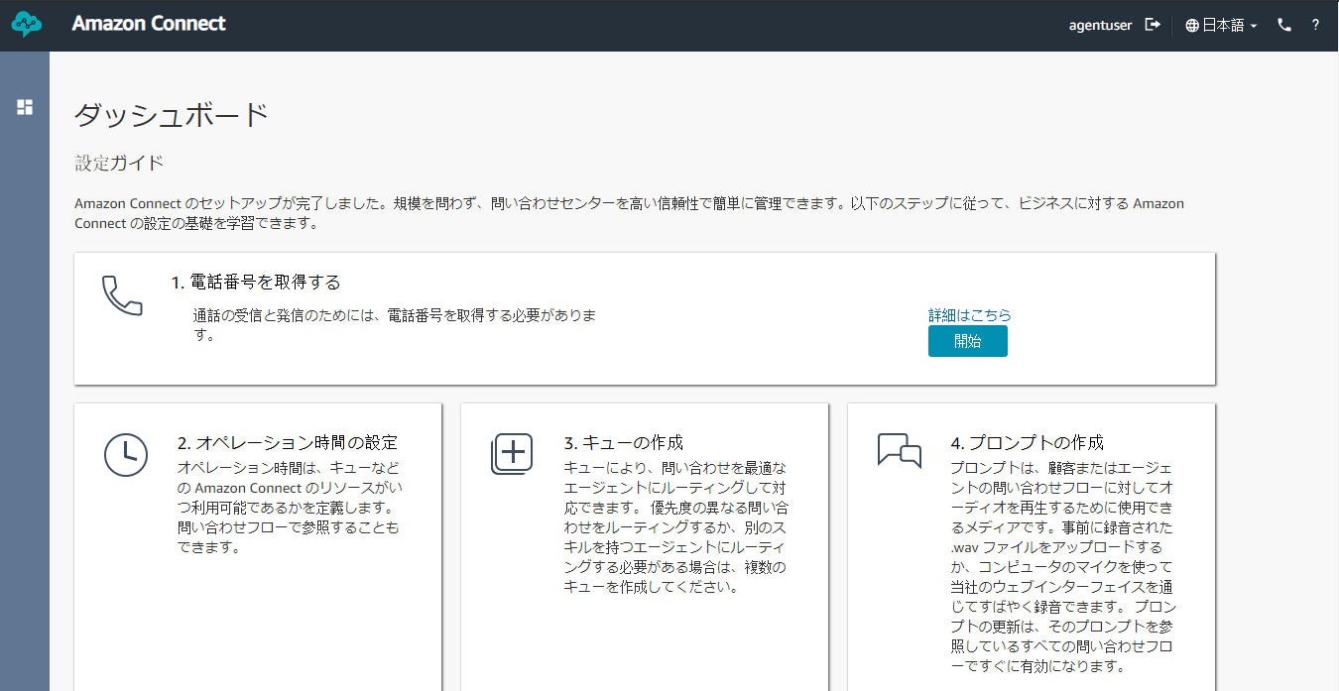

Figure 4. Amazon Connect Agent Dashboard

* Click on the phone icon “” at the upper-right corner of the dashboard. This will open the CCP in a new window.

*Note: On your first log in, your browser will ask your permission to use the microphone. Click “Allow” to be able to use the CCP.*

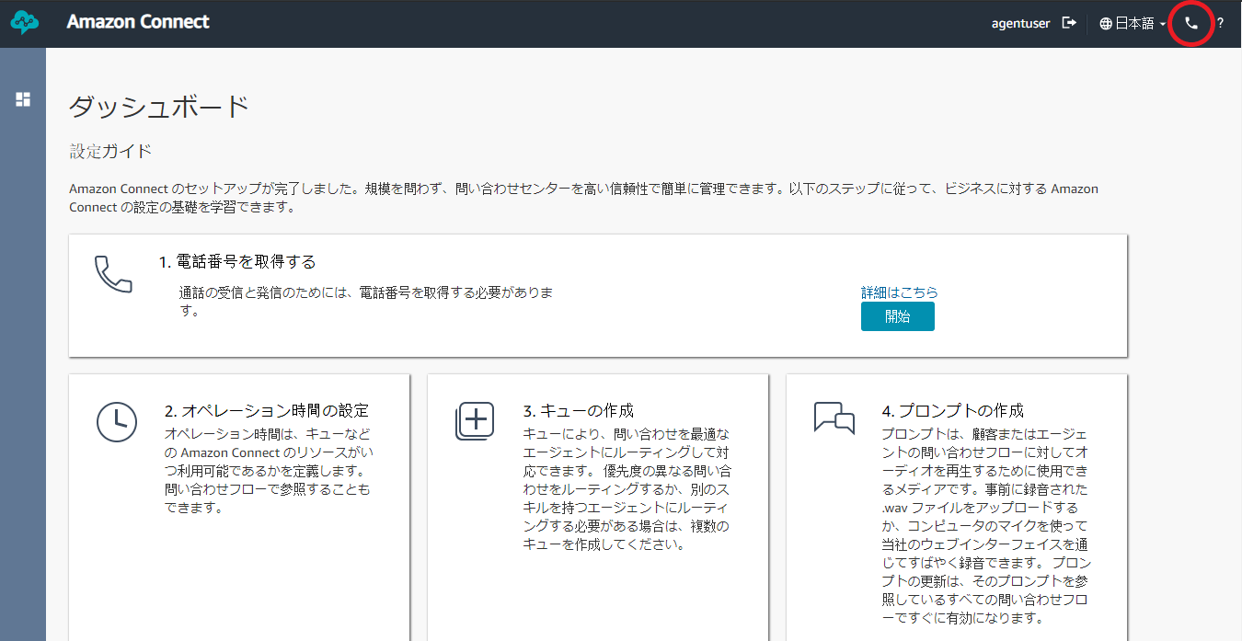

Figure 5. Upper-Right Corner of the Dashboard

* You are now logged into your account and can use the CCP.

# **Changing the Agent Status**

* The agent status will let the IVR know if you will be receiving a call or not. There are two types of agent status:
  + Available – lets the IVR know that you are available for a call. You will be able to receive a call from a customer that is waiting on your respective queue.
  + Offline – lets the IVR know that you are not available for a call. You will not be able to receive any call from any sources. This is mostly used when on meeting, break, or off-work.
  + Amazon Defined Agent Status (Missed Call, Initialization Error, and so on) – these are statuses that displays when there is an error on either the Amazon or the caller or other undefined events. IVR will see you as not available for a call. Set the status to Available to receive call from the queue.
* When you are Offline, you can set your status to Available by clicking on the blue “Set to Available” button.

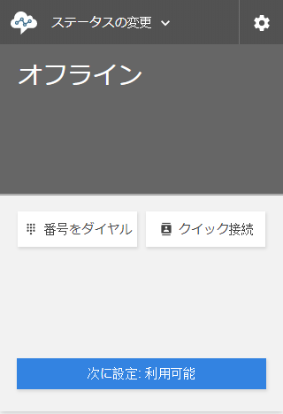

Figure 6. CCP Offline Status

* When you are Available, you can set your status to Offline by clicking on the “Change status” dropdown menu on the top left corner of the screen.

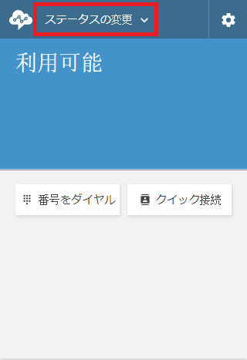

Figure 7. Change Status Dropdown

* Then, click “Offline”.

*Note: You can also set your status to Available through this method.*

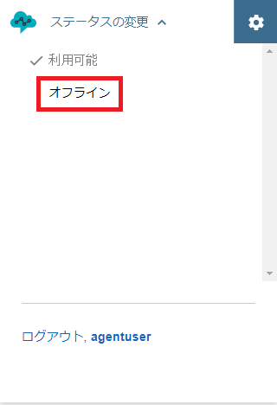

Figure 8. Change Status Dropdown List

# **Answering/Rejecting Calls**

* When you receive a call, you will be given an option to accept it or reject it.

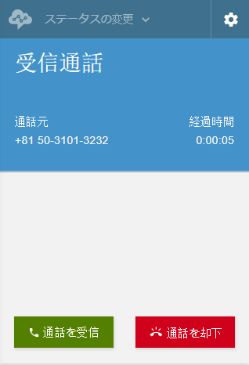

Figure 9. CCP on Inbound Call

* Clicking on the green “Accept call” button will answer the call and you will start speaking with the caller. A voice prompt will tell you the amount of caller still in the queue and from what queue it belongs to.
* Clicking on the red “Reject call” button will reject the call and send the caller back to the queue. Your status will immediately be set to Available, allowing you to receive another call from the queue.

# **Transferring Calls**

* If a customer has an additional concern outside of your scope, you can transfer the caller to another agent who handles those concerns. You can do this by clicking on the “Transfer” button.

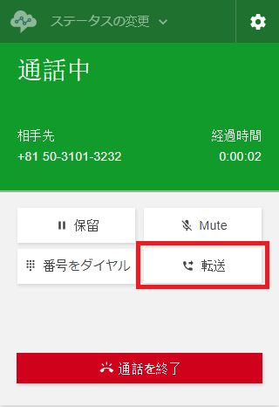

Figure 10. CCP Connected with the Caller

* A list of queues will be shown to you. These are called “Quick Connects”. You can easily transfer the call to another queue or agent through this feature.

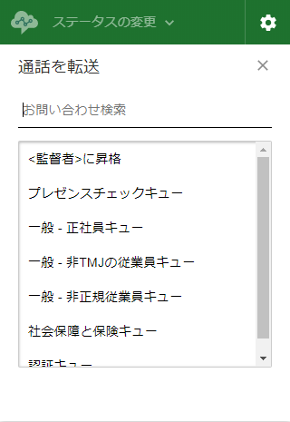

Figure 11. Quick Connect Lists

* Move your mouse over the necessary queue and click the “Dial” button.

*Note: You can also transfer the call to an agent assigned in Escalations through Quick Connects.*

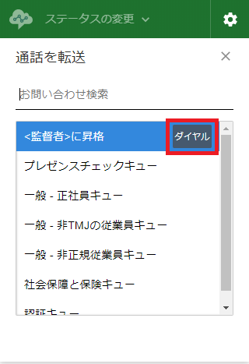

Figure 12. Highlighted Quick Connect

* The call will now attempt to transfer to a queue. This will hold your call with the customer. Wait for the transfer to be connected. The transfer is ready if the Internal-Transfer call status is Connected.

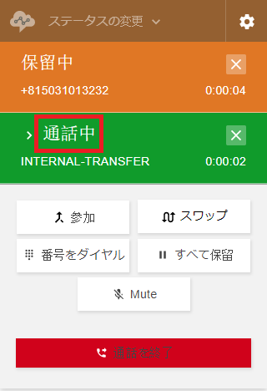

Figure 13. Call Status on Transfer Attempt

* Click on the “Join” button to merge the two calls. You will now be able to talk with both the caller and the agent who answered your transfer.

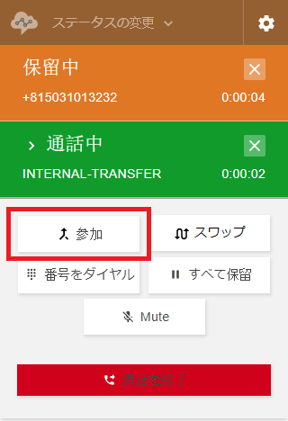

Figure 14. Join on Transfer Attempt

* After introducing the caller to the other agent, click the red “Leave call” button to drop the call. The caller and the other agent will now be talking on the other agent’s line. Your status will immediately be set to “Available” and now ready to receive another call from the queue.

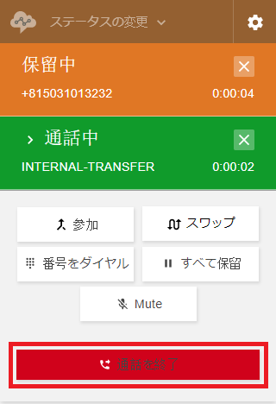

Figure 15. Leave Call After Joining Calls

# **Ending the Call**

* If the caller is not answering, not responding for a long time or an error occurred on their end, you can manually drop the call. To do this, you can click on the red “End call” button. This will immediately set your status to “Available” and now ready to receive another call from the queue.

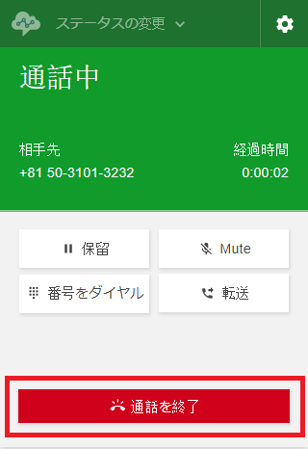

Figure 16. End Call Button

# **Logging out of CCP**

* After your work hours, you need to log out of the CCP. To do this, you need to click on the “Change status” dropdown. Then, click “Log Out, *<Your Username>*”.

*Note: <Your Username> is the username you used to log into your account.*

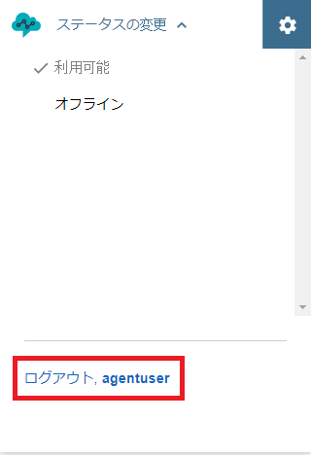

Figure 16. Log Out Link on Change Status Screen